# CS 255 System Design Document Template

This template lays out all the different sections that you need to complete for Project Two. Each section has guidance to prompt your thinking. You will need to continually reference the interview transcript as you work to make sure that you are addressing your client’s needs. There is no required length for the final document. Instead the goal is to complete each section based on what your client’s needs are. Remove this note when you are finished, and replace all bracketed text with the relevant information.

## UML Diagrams

### UML Use Case Diagram

### UML Activity Diagrams

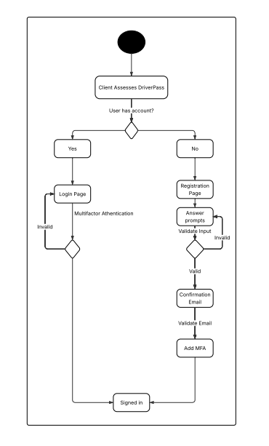

### UML Sequence Diagram

### UML Class Diagram

## Technical Requirements

* The system shall validate user credentials when logging in
* The system shall allow for password resets if the client can answer their security questions
* The system shall allow a set number of attempts to login before locking the client out
* The system shall notify the admin when a “brute force” hacking attempt is made
* The system shall create user accounts
* The system shall show packages to the client
* The system shall allow the admin to remove or add packages
* The system shall show which driver is connected with which client (including date, time, car, etc)
* The system shall receive updates from the DMV for system updates
* The system shall display client information
* The system shall give access to the tools provided in designated package
* The system shall provide feedback to the client from their lesson including how it went, when it was, how long it was, and the instructors notes
* Web-based cloud environment
* The system should run with a load time of a couple seconds
* System updates are based on the DMV and should be updated roughly every month or more if there are more updates from the DMV, a notification will be sent every time the DMV has a new update so the company knows when an update will occur
* The system is web based so it should run on browsers including mobile browsers, i.e. chrome, safari, edge, etc
* The back end would need a web server and a database for storage
* Each user will have their own login
  + Passwords should be case-sensitive for extra security
* The system should be completing a scan at each login to verify user and report back to admin if a problem arises
  + Multi-factor authentication could be utilized to minimize problems
* Changes to the user can be made without changing the code, but would need to be done by the backend team
* Since the system is web-based there should not be any issues with updates, but this will come down to the development team and the code to make sure it is functional in each environment they want it to be functional in
* The IT admin needs access to the server, database, and updates provided by the DMV
* For a user to login they will need a username and password (case-sensitive)
* To secure the connection between client and server the company could utilize multi-factor authentication
* If there is a “brute force” hacking attempt the user would be locked out and would have to contact the Help Desk to be allowed access
* There should be a forgot password option that has the client answer security questions to get an email link to reset password
* For clients
  + Login page
  + Home page
  + Available packages
    - Including what is included in each package
  + Package selected
  + Scheduled drive times
    - Including who the client is scheduled with
  + On road learning history
    - Client should be able to refer back to previous lessons to review the instructors notes
  + Access to online learning tools
* For Admin
  + Client information
  + Client package selections
  + Scheduled drive times
    - Which client is connected with which driver
  + Add/remove packages